**Pseudocode:**

# Define the path to the speech file

file_path = "state_of_the_union.txt"

# Open the file and read its full text into a variable

with open(file_path, "r") as file:

speech = file.read()

# Split the speech into sentences using punctuation (., !, ?)

sentences = split text by sentence-ending punctuation

# Extract all word tokens using regular expressions

words = find all word-like patterns in the text

# Calculate total number of words

word_count = length of words list

# Calculate total number of characters in the original text

char_count = length of entire speech string

# Calculate average word length

avg_word_len = total characters in words / word_count

# Calculate average sentence length in words

avg_sent_len = word_count / number of sentences

# Convert all words to lowercase for consistent counting

lowercase_words = convert all words to lowercase

# Count frequency of each word

word_freq = dictionary of word counts from lowercase_words

# Get the 10 most frequent words

top_words = top 10 entries from word_freq

# Identify unique words

unique_words = set of words

# Sort unique words by length in descending order

sorted_by_length = sort unique_words by word length (descending)

# Get the top 10 longest words

longest_words = first 10 words from sorted_by_length

# Display statistics in a summary table

print word count, character count, average word length, average sentence length, top 10 longest words

# Display top 10 word frequencies in another table

print top_words and their counts

# End of program

**Source Code:**

*"""Title: State of the Union Speech Analyzer*

*Description: This Python script reads a speech from a text file and performs*

*statistical analysis including word count, character count,*

*average word and sentence lengths, word frequency distribution,*

*and the longest words used in the speech.*

*Author: Ian Patricio*

*Date: July 26, 2025*

*"""*

import re

from collections import Counter

from tabulate import tabulate

# Load the speech from a file

file_path = "state_of_the_union.txt" # Replace with your actual path if needed

with open(file_path, "r", encoding="utf-8") as file:

speech = file.read()

# Sentence and word tokenization

sentences = re.split(r'[.!?]+', speech)

words = re.findall(r'\b\w+\b', speech)

# Basic statistics

word_count = len(words)

char_count = len(speech)

avg_word_len = sum(len(word) for word in words) / word_count

avg_sent_len = word_count / len(sentences)

# Word frequency (case insensitive)

word_freq = Counter(map(str.lower, words))

most_common_words = word_freq.most_common(10)

# Top 10 longest unique words

unique_words = set(words)

longest_words = sorted(unique_words, key=len, reverse=True)[:10]

# Summary table

summary_table = [

["Word Count", word_count],

["Character Count", char_count],

["Average Word Length", f"{avg_word_len:.2f}"],

["Average Sentence Length (words)", f"{avg_sent_len:.2f}"],

["Top 10 Longest Words", ", ".join(longest_words)],

]

# Display summary

print("\nSpeech Summary:")

print(tabulate(summary_table, headers=["Metric", "Value"], tablefmt="fancy_grid"))

# Display word frequency

print("\nWord Frequency Distribution (Top 10 Words):")

print(tabulate(most_common_words, headers=["Word", "Frequency"], tablefmt="grid"))

**Screenshots:**

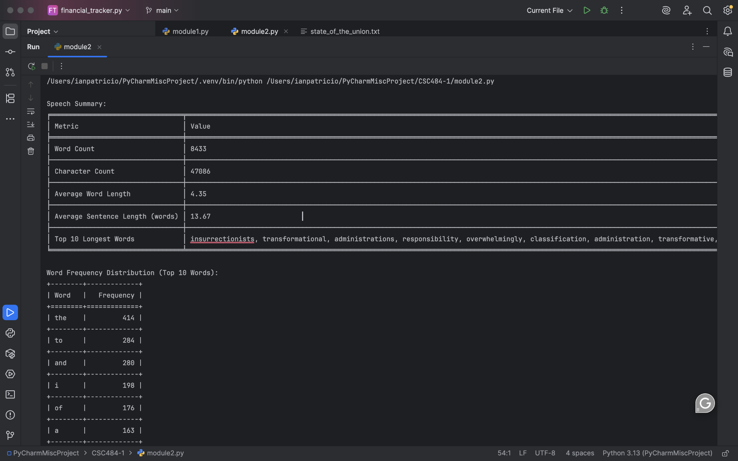

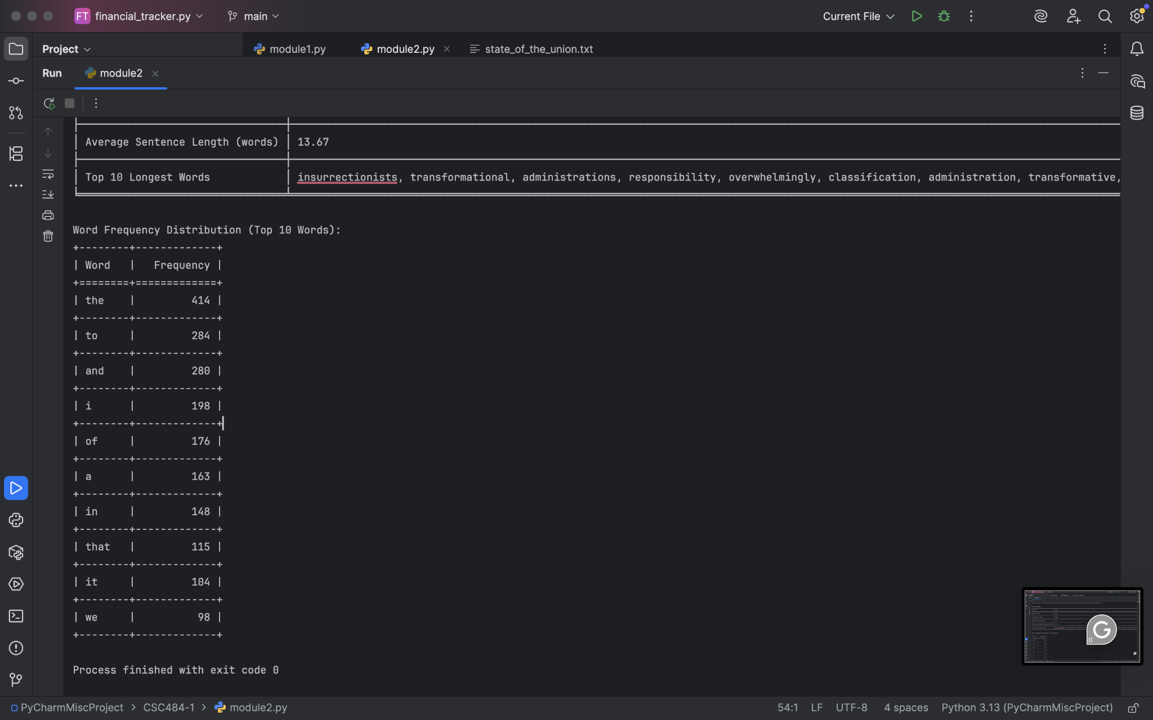

**Git Repository:**

https://github.com/ianpatricio-csuglobal/CSC484-1